Contents

Test Table 2

Appendix 4

Logging In: 4

Log In Validation: 5

Access Levels: 6

Associate Viewing: 7

Admin Viewing: 8

Program Run Errors: 9

Exit 10

# Test Table

|  |  |  |  |  |  |
| --- | --- | --- | --- | --- | --- |
| Test Case Name | Description | Test Step | Expected Result | Actual Result | Appendix |
| Logging in | When the user presses the “log in” option at the top left of the interface the user will be taken to a page where they can choose the associate login or the admin login. | The user will enter their username and password. | When the user enters their username and password the program should accept this and take them on to the next page. | Pass – the program takes the user to the next part of the program. | See in the appendix (page 4). |
| Log in validation | When the user clicks “log in” the interface will bring up the 2 log in areas. These 2 log in areas will have their own separate validated fields so only the correct credentials can be entered. | The user will enter the username and password wrong. | When the user enters their username and password the program will clear the fields that they have entered as it will be the wrong credentials and will allow them to enter again. | Pass – the program will clear the fields that they have entered wrong. | See in the appendix (page 5). |
| Access Levels | The 2 different log in areas (Admin and Associate) will have different access levels as a security measure. | The user will display the different uses of the Admin and Associate. | The admin will be able to add new employees and view their information whereas the employees will only be able to view their own information and payslips. | Pass – the program has 2 different layers that allow for different access levels so the employee can’t access the admin stuff. | See in appendix (page 6). |
| Associate Viewing | After the user has logged into the associate field, they can view their payslip and time off requests. | The user will show the options to view the payslip and time off request. | The user can click the option to view the payslip and it shows the table which displays their information, and the user can click on time off requests which displays the time, date and reason. | Pass – the program allows the user to view the payslip with ease and input information for time off. | See in appendix (page 7) |
| Admin Viewing | After the user has logged into the admin field, they can add new employees and view. | The user will show the options to add new employees and view. | The user can click the option to add new employee which comes up with a vast array of things to enter and the user can click on view which views the employees’ details. | Pass – the program allows the user to add a new employee with lots of information and then also allows the user to view this information they have added. | See in appendix (page 8) |
| Program Run Errors | When the program is running there is no errors, and the program boots up very quickly. | The user will show this by running the program. | The user can run the python program and on the home screen there will be no errors and it will be smooth. | Pass – the program runs with no errors and boots up fast. | See in appendix (page 9) |
| Exit | There will be an exit button alongside the log in button that can be used to exit the program. | The user will show this by clicking the exit button and showing it exiting. | When the user presses the option to exit the program there should be no errors and it should go back to the python code. | Pass – the program closes with no errors. | See in appendix (page 10) |
| Privacy Policy | There will be an area to click to view the privacy policy and accept it to ensure the user knows what they are agreeing to. | The user will display this by pressing click for more info on the privacy policy. | When the user presses the more info, it displays the text which tells the user all about how their personal information is used. | Pass – the program displays the privacy policy to the user, allows them to back out of it and will prompt that when they login it will accept the policy. | See in appendix (page ) |
| Payslip Calculations | In the employee area the details can be put in for the payslip of the employee and all calculations should be made correctly. | The user will enter some details about an employee and show how the calculations work. | When the user enters the information the tax and all other pay information is displayed in the correct places. | Pass – The program does the calculations with no errors. | See in appendix (page ) |
| Employee Adding | In the admin area there is a section where information about the employee can be added like their name. | The user will enter the details about the employee and show that this data is now being displayed when they view the employee. | When the user enters the information, it is displayed in the view employee details option. | Pass – The program saves this data in the database and displays it to show all employees. | See in appendix (page ) |

# Appendix

## Logging In:

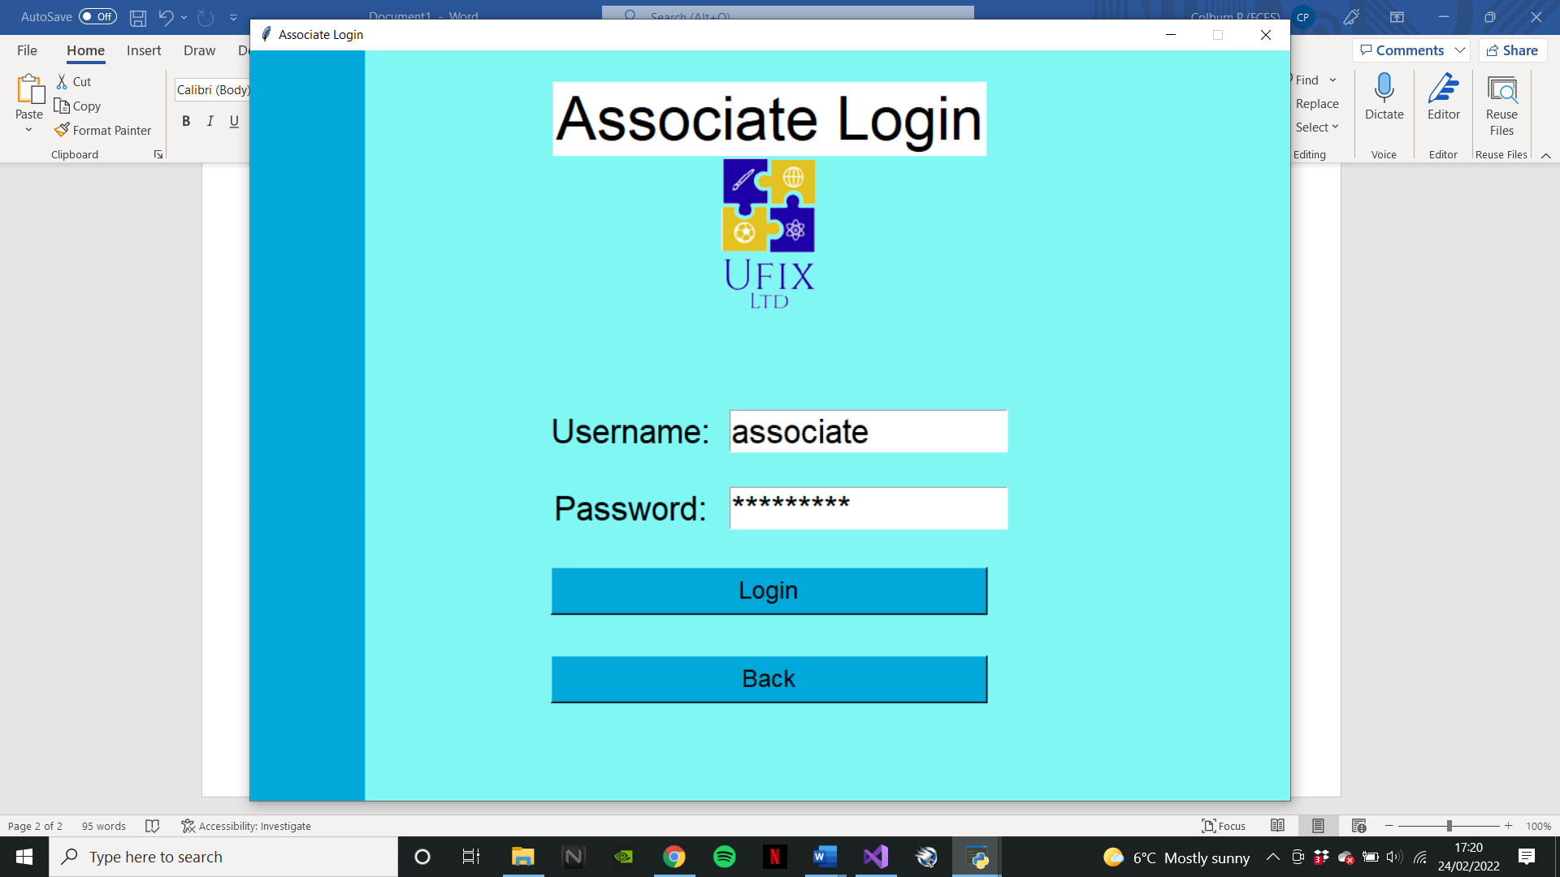

## Log In Validation:

## Access Levels:

## Associate Viewing:

## Admin Viewing:

## Program Run Errors:

## Exit

## Privacy Policy

## Payslip Calculations

## Employee Adding

